Board
Marketplace
Solution Page
Template

This template provides you the guidelines for the creation of the marketing material dedicated to your Solution page on the Board Marketplace.

Solution page template
Please fill in the template with the required info in each box, once complete please send it to marketplace@board.com or your local Board contact.
The template contains a blank box to fill as follow.
- TITLE (Solution title)
No longer than 10 words.

- SUMMARY (Solution summary)
No longer than 150 words.

- BODY (full description of the Solution’s main functionalities)
Solution Description No longer than 300 words.
4. INDUSTRY (if industry specific, which industry is covered by the Solution)
5. SOLUTION SCREENSHOTS AND VIDEO (screenshots or video of the different screen)
The Solution page will contain no more than 6 Screenshots -Format JPG/PNG – Size 1920x1080 px.
Video-should be no longer than 3 minutes – All format supported, if available MP4 format is preferred.
The video is highly recommended but if not available only screenshots will be uploaded.

6. LOGOS
The partner company logos (2) – Format PNG – one in colour and one in white, both with a transparent background – Minimum dimensions 400x300 px.
In case an Solution logo exists, follow the same rules as per the company logo.

7. OTHER
In case in which is already developed a documentation related to the Solution as Brochure etc. please attach the document at the e-mail in addition to this template.
We give the opportunity to upload it as support documentation to the Solution.

This information will create the Solution page of your application as the image below.
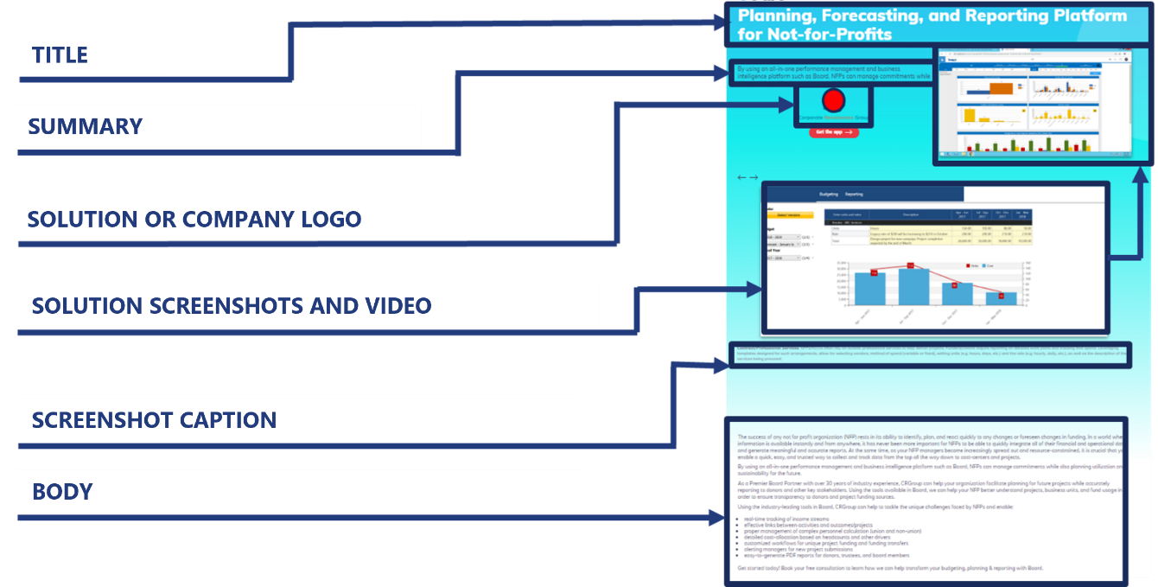

TitlE
Click or tap here to enter text.

Summary
Click or tap here to enter text.

BoDy
Click or tap here to enter text.

INDUSTRY
Click or tap here to enter text.

Solution screenshots

Screenshot Caption:
Click or tap here to enter text.

Screenshot Caption:
Click or tap here to enter text.
Screenshot Caption:
Click or tap here to enter text.

Screenshot Caption:
Click or tap here to enter text.

Screenshot Caption:
Click or tap here to enter text.
Screenshot Caption:
Click or tap here to enter text.

Solution or company logo
Logo 1

Logo 2

